Alex Stewart

BCDE311 – Software Development PROJECT

Semester 1, 2024

Ara ict virtual orientation tour for christopher bartlett

final project documentation

Version 1

Contents

Introduction 5

Project Details 6

Project Name 6

Overview of Industry Client 6

Project Background 6

Information Gathering 7

Documentation 7

Project Scope 10

Project Goal(s) 10

Benefits of Project 10

Project Requirements 11

Expected Deliverables 11

User Personas 12

Project Plan – High Level 14

Project Management Framework adopted 14

Phases 14

Timetable 14

Burndown Charts 16

Resources/Access Required 16

Risk Management 16

Approach 17

Risk Table 18

Quality Assurance 20

Approach 20

Quality Assurance Table 21

Test Plans – Functional and Usability 23

Project Management Framework Methodology 27

Overview 27

Literature Review 27

Critique (Pros and Cons) 28

Ethics 29

Relevance of ITP Code of Ethics 29

Relevant Legislation 29

Reflections 32

Approach 32

Specifications 33

Reference List 40

Appendices 41

Appendix A – Detailed Project Plan 41

Appendix B – Risk Management Table 41

Appendix C – Quality Assurance Table 41

Document Control

|  |  |  |  |
| --- | --- | --- | --- |
| Date | Author | Version | Status of Document/Updates Made |
| 12/03/2024 | Alex Stewart | v0.1 | Document Creation |
| 16/03/2024 | Alex Stewart | v0.2 | Project Details Completed |
| 28/03/2024 | Alex Stewart | V0.3 | Information gathering documentation started to be completed |
| 01/04/2024 | Alex Stewart | V0.4 | Added and completed my Project scope information |
| 03/04/2024 | Alex Stewart | V0.5 | Touched up on the information gathering/interview reports and updated the must haves in accordance. |
| 06/04/2024 | Alex Stewart | V0.6 | Added some testing plans |
| 10/04/2024 | Alex Stewart | V0.7 | Added information on the project framework which will be used – benefits and why. |
| 11/04/2024 | Alex Stewart | V0.8 | Interview transcript fully written up and added to report |
| 12/06/2024 | Alex Stewart | 0.9 | Added prototype evidence and iterative development/ testing evidence. |
| 17/06/2024 | Alex Stewart | 1.0 | Submitted Final Product |

# Introduction

This document aims to inform the customer, what the plans for the project are, how it is aimed to be completed, and what steps will be taken to achieve a successful product. Some useful things which will be discussed in this report are the development methodologies which will be used, the project scope, risks which may impact the success of the project, and how they can be mitigated, how I will ensure quality throughout the creation of this product, privacy concerns, ethics and much more.

# Project Details

The ICT Orientation Virtual tour will aim to offer the experience of a virtual, online tour, of the Ara Institute campus in the city centre, which will be aimed at ICT students. This will aid them in acquiring knowledge of what is around the campus, especially if the in-person tours cannot be held or they have other commitments for personal reasons.

## Project Name

**Ara ICT Orientation Virtual Tour.**

## Overview of Industry Client

Christopher Bartlett is an ICT tutor at the Ara Institute of Technology. He is wanting a virtual tour available for students to use.

## Project Background

The following information was gathered through an interview with Christopher Bartlett, the client of this project. More specific details of the interview can be seen in the information gathering section of this report.

### Overview

This project is important to our client, as some students may be sick or unable to attend the virtual tours, which may cause issues with finding important areas on campus. Covid has also been running rampant meaning that in person confrontations are being affected, so that students are unable to get a tour of their study areas. This means that Chris is wanting a consistent and sustainable option for students to opt for if anything is to go wrong.

### Current Situation

The client currently needs a virtual tour application to be completed, to show students an up-to-date version of Ara and what it looks like.

### Future Situation

The client will have a viable and quality virtual tour, which can be displayed and used by students in a successful manner. The tour is professional and simple to use, yet effective in displaying information.

# Information Gathering

This section will cover key information gathering and how it was obtained, namely through an interview which was held with the client. The questions which were asked will be included in the documentation part of the report and will then have the Interview notes which were made by the interviewer below. The questions are split into different themes.

## Documentation

### Interview questions.

**Identity Questions**

* Tell us about Ara.
* How long have they been around?
* Who are the main users of the product.
* Tell us about what the project will be.
* What details or contents you want to be in this project?
* What is your goal with the 3D orientation tool?
* What would you like your users to see/feel when interacting with the solution?
* Are there any concerns or areas to watch out for?

**Design Questions**

* When it comes to accessibility, do you want this product to have elements of Responsive design (Font sizes change, mobile friendly)?
* Can you discuss what is the ideal interactions the users to have on this project?
* Are you wanting to keep the colour scheme and font styles from the official Ara website?
* If yes, Do you want Ara's blue design tones or Te Pūkenga's green, with associated logos?
* Do you envision a simple click-through solution for the orientation website and virtual tour, where users can navigate through the content with minimal interactive elements?
* What media elements you want to be included?, If yes, do you want any audio based guides or descriptions?
* Would you like faces blurred/identities of people in images obscured or would you like to focus on the human approach and highlight people with positive connotations highlighted?
* With each location (picture), do you want us to include some sort of description of it?
* Do you want to see and be involved in the initial prototype before our final?

**Functionality Questions**

* Do you have access to the original resources?

Assets like logo + other images.

* How many different picture locations would you like?
* Would you like any locations to be a focus?
* What kind of weather would you like the outdoor shots to be taken in? If that's a concern
* Do you want any activities highlighted? (Basketball, clubs, etc)
* Do you want other campuses or locations included or just Madras Street campus?
* Do you want all locations, outdoors and interiors or just the ones students can interact with?
* Do you want language options for different students first languages?
* What are the must have features for this software? And could haves?
* Are there specific interactive elements or features you envision for users when exploring the 3D orientation tool nav around info hot spot.
* Do you anticipate the need for customizable features within the 3D orientation tool, such as the ability to tailor content based on user roles (students, faculty, staff) or personal preferences?

**Maintainability Questions**

* Do you want hands off, near zero interaction with backend?
* Will the solution be locally hosted using Ara infrastructure, or hosted online via other company?
* Do you want to be able to edit the solution via admin options or something like that?
* Is there a budget allocated for paid solutions?
* Do you want a proof-of-concept high level prototype or a standalone functional solution ready for handover/presentation/publication to new students?
* Do you intend on gathering feedback from users, and if so, how do you intend on gathering it.
* Do you have plans for future expansions or updates to the 3D orientation tool, and how do you envision incorporating new features or content down the line?
* Are there specific key performance indicators (KPIs) or success metrics you would like to track to measure the effectiveness and engagement of the 3D orientation tool over time?

### Notes / take-homes from the Interview.

* **Ara is a job-oriented polytech.**
* **Ara has been around for 11 years.**
* **The main users of the product will be new students, who are studying ICT at Ara. Parents could possibly be users as well.**
* **They want visually guided ways around the campus to be displayed, and in particular needs to be catered for ICT students.**
* **The tool needs to be easy to use and not over complex, explaining needs to be minimal.**
* **Need to look out for balancing the amount of detail that I add to the page, keep it simple**
* **Need to be aware of privacy concerns, in particular, blurring peoples faces.**
* **Needs to be usable on ipad, iphone, computer etc.**
* **Needs to use colour schemes from Aras website.**
* **Could use sound? But maybe worry about text to speech in version 2.**
* **Each location needs a description of where it is/what it is.**
* **Need a prototype made on the actual application in order to display what the end product will look like**
* **We have access / legal rights to the use of Ara IP, (Logo).**
* **Must take 360 degree photos of ara campus using the 360 degree camera.**
* **Users should have a choice on which entrance to start the tour at, but entrance 9 (main entrance) should be the default option if they don’t pick one.**
* **Weather when taking photos should be bright/sunny, consistent inside and out, and bright. Trees shouldn’t be bare.**
* **Must Show facilities that ara has around the ICT rooms/ campus.**
* **Only needs to be the campus in city center.**
* **Show important buildings like security, ICT help desk etc.**
* **Version 2 should have language options**
* **Need text descriptions / photos / videos , audio can come version 2 and TTS is not a must have, but a could have.**
* **Do not need staff tailored content like staff log ins etc.**
* **Interaction needs to be hands off, meaning automated server hosting etc.**
* **We will initially host through our own means, as the ara hosting facilities can be complex to get sorted.**
* **Product should be standalone / ready to be deployed when finished. Just drag and drop into their own hosting facility sort of thing.**
* **They do not want KPI’s (seeing statistics of how many people visit the site). It is outside of the scope.**

# Project Scope

This section will describe what is expected when it comes to the final product, like the goals which are set, requirements which need to be completed by the end of the project, the benefits that the completed project will have, the deliverables which are expected, and the user personas of the product itself.

## Project Goal(s)

* The client will be able to display a usable and professional product for Ara ICT students to use, to virtually tour the campus. Meaning it can be toured through a phone, laptop, iPad etc.
* The product will have suitable photos which are easy to identify for the users, on where to go and where things are around the campus.
* The users will find the product (on average) simple and easy to use and will not be faced with a complex virtual tour.
* ICT students will be able to learn about where abouts of where they will be studying if they need help identifying locations on the campus.
* The photos are recognisable and depict and accurate representation of the Ara campus.
* Users who do not speak English should have an option for switching language, to read the descriptions of the locations.

## Benefits of Project

Some benefits of the project include:

* The virtual tour is easily accessible for students who are absent from the orientation day.
* The virtual tour is a simple, cheap, and relatively easy substitute choice if there are issues with hosting the in-person tour on the day, for example, if covid is running rampant.
* The tour provides an interactive hands-on experience for people which may help them remember or learn about the Ara campus.
* The project is sustainable as it reduces the need for physical travel and potential printed materials, (if Ara was to ever decide to stop hosting the physical orientation tours).
* The virtual tour is easily scalable, as other parts of the campus can also be added if the scope changes.
* Virtual tour ensures all students who use it are viewing the same information, meaning a smaller chance for misinformation as they are all consuming the same information on the page.
* A virtual tour can be time efficient for the users, as it may mean they do not have to drive in and out to be at the physical tour. This also tags onto environmental sustainability.

(forgemountain, 2024)

## Project Requirements

The virtual tour must include the following locations:

* Entrances to campus
* ICT office
* Main areas where ICT staff offices are
* Main classrooms which are used by ICT students, (X,S,N,W Block)
* Main atrium
* Security desk
* Library
* Learning Disability services
* IT support help desk
* Whareora building
* Gym
* Student health
* Early childhood education centre
* Te Puna Wanaka
* The pantry cafe
* Car parking (main park off barbados st)
* Student lounge in C block

## Expected Deliverables

Primary deliverables are deliverables which need to be completed and have been specified as a clear requirement for the project. The secondary deliverables are deliverables which have been mentioned but do not need to be completed for the minimum viable product, or version 1. This information was gathered through the interview with the client.

**Primary Deliverables:**

* All locations mentioned in the requirements must be listed in the virtual tour.
* Resizable options for different screen sizes
* Each location will have a clear description of what/where it is.
* Images will be in a 360-degree format.
* Product should be hosted through an online hosting application.
* It should have minimal or no need to interact with the product once it has been deployed. (automated).
* Weather needs to be consistent inside and out. Should be sunny and bright.
* The page will use the colour scheming of Aras home web page.
* A prototype of the application will be delivered to the client before the launch of the product.
* Options for users to select which entrance they wish to start at.

**Secondary Deliverables:**

* Language options for users who do not speak English
* Text to speech options

## User Personas

The ICT orientation virtual tour was specified to have two target users.

The first and main user of the product is going to be ICT students who are intending to or do study at Ara. This was mentioned in the interview. It was also briefly mentioned that parents may also be users of the product.

People who will be using this product can range from young people who are fresh out of high school studying, to older people who are looking to have a career change later in life. This means there are many different personas which we must consider when it comes to creating the virtual tour.

The point of this section is to indicate and evaluate what sort of users we can expect to be using our products. This includes a lot of empathising and thinking about how different people might act/think when they are using our product. Everyone is slightly different and unique in their own ways which means not everyone will use the product in the same ways. (hotpmo, 2024)

The following user personas are accurate depictions of what typical users of this product/virtual tour will be.

**User persona 1: New BICT student at Ara.**

Age: 21

Gender: Male

Location: Christchurch, New Zealand

**Goals and Objectives:**

The student wishes to learn about what there is to explore at the Ara campus and wants to become more familiar with where they will be studying when they start the semester. They currently have limited to no knowledge about what the campus offers.

**Motivations:**

The student is driven to excel and complete a bachelor's degree in ICT so that they can obtain a good job in the ICT sector. They love technology.

**Behaviour and Frustrations / Pain Points.**

The student is shy and has decided that they will not turn up to the physical orientation day. They find it very annoying when things are not simple to use and causes them emotional frustration.

**Technology / Devices**

The student uses both a laptop and a smartphone. Depending on whether they are at home or not, the student prefers to use a smartphone when they are away from home, but their laptop when they are at home. Their laptop uses windows 10 and their phone uses Apples operating system.

**Analysis from user persona 1:**

This user seems to be a very typical ICT student. They are relatively young and are looking to get into technology and wish to complete a bachelor's degree at the Ara institute of technology. They do not like interfaces which are difficult to use and like ease of use / flowing information. Since the student is shy, they will most likely choose to use the virtual tour to obtain their information about the campus and where they will be studying. They use a laptop and smartphone, meaning that the product, as stated above, will cater towards both devices as it will have resizable screen sizes. It also will cater towards the most common operating systems: Linux, Apple and Windows.

**User persona 2: Parent of 18-year-old cyber security certificate student.**

Parent age: 48, daughter is 18.

Gender(s): Female, Female.

Location: Christchurch, City, New Zealand

**Goals and Objectives:**

The cyber security student wishes to complete a certificate which Ara offer, in Cyber security. They wish to do this so they have a quick and easy study option which will open options for them into the job market for networking.

**Motivations:**

The student wants to take after her mother who is a cyber security analyst.

**Behaviour and Frustrations / Pain Points.**

The student is competent when it comes to using technology but has been very busy finishing work before her study begins. Her mother has opted to view the virtual tour for her and give her any key information. Her mother is not very tech savvy and often leaves sites which are not user friendly or support ease of use.

**Technology / Devices**

The parent is going to be using her phone to view the virtual tour application, but also has a home computer that she can use as well. The phone is a Samsung galaxy, and the laptop is an apple laptop (MacBook pro)

**Analysis from user persona 2:**

The parent seems to have an influence on her daughter, and her daughter also seems to have an interest in cyber security. Since the daughter is so busy, the parent has decided that she will try to gather some information for her through the virtual tour option that is being presented by Ara.

The parent is not very tech savvy (even though she is a cyber security analyst) and likes ease of use when it comes to using products online, such as the virtual tour.

# Project Plan – High Level

This section of the report will show important features such as the framework of which I intend to use in order to complete a structured development of the project, documentation of the phases of the project, a timetable with time estimates and an order for which each task is expected to be completed in, a burndown chart which shows the predicted amount of hours which are left on the project, versus the actual amount of hours left.

## Project Management Framework adopted - Kanban

The framework which will be used for this project is going to be Kanban. Kanban allows for flexibility, reduced waste, and increased efficiency when managing a project. This framework has a Kanban board which is a visual representation of the workflow, which is usually divided into columns which represent various stages of work to be completed. Individual items of work are also represented by cards or tickets which are located on the Kanban board. Each card has information such as a title, description, assignee and a due date. The framework facilitates WIP limits, meaning that a board cannot contain too many items which may clutter and overload the board, allowing for a steady flow of work for the project workers. Finally, Kanban uses a backlog which is a list of work items that are yet to be scheduled or prioritised for their implementation. The backlog items are typically given a priority number and can be added to the workflow when space becomes available. (Hayuhardhika, 2020)

## Phases

For this project, it will consist of 8 main phases. Inside of these phases are tasks or activities with time estimates and date estimates for which they will be completed.

The phases are in ascending order of project completion:

### Phases of Project:

#### Empathise

This phase will investigate the projects core requirements, through an interview with the client

#### Define

This phase will analyse important aspects of the empathise phase, define project scopes and requirements, plan risk analysis and tests for quality insurance. It will also touch on ethical considerations. Final phase for the project proposal.

#### Ideate

This phase is about refining our ideas, and creating simple and usable foundations for which the project can be built on. Things like sketches of what the product could look like, design features, and media assets will be gathered.

#### Lofi Prototyping / Testing

This phase consists of interviewing the selected users, creating simple wireframes, implementing and tweaking functionality and usability testing, analysis of the testing, refining of the prototype through the results, and touching on the risk assessment for a second time.

#### Hifi Prototyping / Testing

This phase will prepare our images that will be used in the virtual tour, and then we will create a prototype which will closely depict the final product. We must then implement and pass our functional and usability testing and then further refine our prototype. After this we will iterate through the prototype into the next HiFi plan.

#### Hifi Prototyping / Testing (using the actual application)

After our initial touch base with the first Hifi prototype, we will use the chosen application (Lapentor) to create and refine an iterated hifi prototype which will closely resemble a final product.

#### Hifi Prototyping / Testing – Functional/Usability Tests

Here we will test our prototype furthermore by making sure that it passes our functional tests and usability tests, and we will refine is based on the results we are given. We will then prepare the product through a presentation and can gather feedback through the presentation.

#### Product Implementation / Final Testing

This is our final phase where the product is refined into the final stages, carrying out our last lot of usability and functionality testing, touching base with all of our risk assessment plans, and completing our quality assurance documentation.

## Timetable

**Please refer to the timeline excel file attached. (BCDE_111_Ass3ProjectPlanAndPhases)**

## Burndown Charts

**Figure 1**  
*Academic Burndown Chart for Visual Orientation Tool – Halfway point.*

**Figure 2**  
*Academic Burndown Chart for Visual Orientation Tool – Finished Final Product / Project Completion.*

# Risk Management

Implementation of risk assessment in a project is critical to ensuring its success in the case that anything goes wrong. Below is the approach that I will take when it comes to assessing risks, and the process of which we will mitigate the risks.

## Approach

This project will utilise a risk assessment table to monitor and mitigate risks which may occur and may also cause project delays and problems. A risk can be defined as any factor which may significantly change or affect the success or product of a given project. This means the deliverables may be delayed or changed due to the occurrence of a given risk.

## Risk Table Details

The risk assessment table has unique risks which pose a threat to the development and completion of the project. These are all identified as risk ids or risk numbers easily visible in the table.

The table also includes what the risk is and what the consequences of the risk occurring are. I have also added a probability of the risk occurring and the impact the risk occurring will have, ranging on a scale of 1 through 10. 1 being the lowest and 10 being the highest. There is also an exposure factor, mitigation tab, contingency plan tab and finally the triggers or signs that the risk may be occurring or has occurred.

The risk assessment table has been created to an industry standard using the Microsoft risk assessment table template as a reference.

More risks may be added during the production of the project where needed.

I have added a mitigation plan which is a plan on how to prevent or get rid of the risks from occurring.

The contingency plan is a plan which if the risk occurs, what the next best option to do is.

Triggers of the given risk condition are warnings that the risk may be occurring or starting to occur. This may allow for a fast response or even able to mitigate the risk through the mitigation statement.

### Impact, Probability, Exposure

The impact is a scale which represents the level of impact that the given risk condition will give the project. The scale will vary from 1 through 10, 1 being low and 10 being high respectively.

Probability is a value of how likely the risk is to occur during the project which ranges from greater than 0 percent to 100 percent.

Exposure is a value which is calculated by multiplying both the impact and probability value together. This will in turn give a value which represents the exposure of the risk condition and will be able to represent how dangerous it may be to the project.

### Risk Table

**Table 1**  
*Risk management table version 1*

|  |  |  |  |  |  |  |  |  |
| --- | --- | --- | --- | --- | --- | --- | --- | --- |
| Risk # | Risk condition | Consequences | Probability of occurrence | Impact Score | Mitigation | Contingency | Triggers | Exposure Score |
| 1 | Project Worker Sick/Injured | Project development will come to a halt causing delays and potentially meaning the project time frame will need to be extended | 50 % | 9 | Eat healthy, complete work on time, don’t take physical risks, stay away from sick people, take vitamin c | Visit GP, eat healthy, rest well, use laptop while resting if I am well enough to use | Runny nose, Sore throat, Broken bones, fever symptoms. | 4.5 |
| 2 | Equipment Stolen/Broken | Data loss, pause in project development, money loss. | 25 % | 9 | Keep equipment in a safe kept place | Ensure devices have passwords, ensure data is backed up on the cloud, have backup equipment available. | Equipment visibly broken or stolen. Slow laptop | 2.25 |
| 3 | Internet Outage | No communication between me and client, cannot produce work for the client either / work on project. | 10% | 9.5 | Choose strong internet provider, use a trusted provider with good security and up time | Ensure I have a secondary location to goto which has internet, in the case that my current location has an outage | Internet not working | 0.95 |

|  |  |  |  |  |  |  |  |  |
| --- | --- | --- | --- | --- | --- | --- | --- | --- |
| 4 | Data breach or Hacked equipment | I will have to use time and resources to either get them back or renew the equipment. It will also use my time of which I am using on the project. | 5% | 8 | Use reliable data keeping services, also use reliable operating system, store data securely with encryption. | Keep data stored on a cloud as a backup, in the case that it Is seized or stolen. Have backup equipment if possible | Equipment has virus, data is missing. | 0.4 |
| 5 | Project burn out | Will lose motivation to complete the project as I have been doing too much work on it in one period of time. Project can start to lack behind schedule. | 10 % | 2 | Make sure you are completing the correct amount of work every week, and not over working yourself in certain periods of time | Take a day to rest mentally and re assess what you should be doing. (maybe use motivation that you need to do it because you want a degree) | Poor motivation, over worked. | 0.2 |

(iqanz, 2024)

# 

## Post Project Completion Risk Details

During the completion of this project, I had to formerly access the risk table I had created twice to check for what to do for an occurring risk. At one point, I had just completed a lot of documentation in one week, so I had to ensure that risk #5 was being dealt with appropriately. I had to re assess as the previous few weeks I hadn’t been completing enough work, leading to a large amount of work being completed in one sitting. Though this didn’t impact the project significantly, I felt the burn out and lack of motivation to achieve a quality outcome. Therefore, I took two days off doing any form of project work at Ara.

I also had an encounter with being sick, and although I exercise and eat well most days, there really wasn’t anything I could do to prevent this. Instead, I had to focus on damage limitation. I was bed bound for three days, however, luckily, I had stayed on top of my work prior and therefore there wasn’t a significant impact on the completion of this project.

# Quality Assurance

This section will describe how I plan to ensure a quality product is delivered for the client. This will include the usability and functionality testing test plans, the approach I will take to complete them, and a quality assurance table.

Usability testing is more orientated towards how easy to use the given application is. Whereas functional testing tests how well functioning the application is, like making sure everything works as it should, and it is functioning as expected.

## Approach

For my project I will be using the Six Sigma methodology to ensure maintainable quality assurance throughout. This framework will allow me to identify and eliminate defects or errors with the project, leading to higher customer satisfaction and reduced costs. Six sigma focuses on measurement, analysis and continuous improvement. It provides a structured framework for achieving and maintaining a high level of quality in the project deliverables. (HAYES, 2024)

It follows a DMAIC process.

* **Define** a projects goals and requirements.
* **Measure** current process performance and gather data.
* **Analyse** the data to identify the causes of issues with the product.
* **Improve** processes by improving and implementing solutions to address issues.
* **Controls** – Create controls to sustain improvements and prevent project regression, to ensure quality and efficiency.

To implement usability testing into my project I will Identify the target users for my virtual tour application, and I will also set out tasks that I wish them to complete, I will measure task success and satisfaction by the user. I will also ensure that the participants who are doing the testing correctly align with what I want my target user group to be, e.g. people within the age range of roughly 18-65. Then once the tests have been completed, I will gather data from my testers and analyse the results which will overall give me an idea of what to improve on the usability side of my virtual tour.

I will also implement functional testing for my virtual tour application, I will do this by firstly defining what my functional requirements for my tour will be, this will give me an idea for when I receive feedback from the testers on how well my tour is performing. I will then develop test scenarios for my testers and create test data, which will be used along with my expected results for each scenario. I will then gather the data from the users and analyse what needs to be changed and how well I have developed the functional side of my virtual tour.

## Quality Assurance Table

The quality assurance table identifies:

* Project deliverables that integrate quality assurance.
* Quality standards and the expectations of all stakeholders in relation to the deliverables.
* The activity – examples being code reviews or audits.
* The intervals for which quality assurance activities will be performed throughout the project.
* Reporting techniques for delivering the quality assurance information.
* Due date / date of acceptance.

The table below is reviewed and accordingly updated after each deliverable gets accepted.

**Table 2**  
*Quality assurance table version 1*

|  |  |  |  |  |  |  |
| --- | --- | --- | --- | --- | --- | --- |
| **Project Deliverable** | **Quality measure** | **Quality assurance activity** | **Frequency / Occurrence** | **Who is responsible** | **Due date** | **Date of acceptance** |
| **Project proposal** | Acceptably covers the scope of the project | Submit the report draft to tutor | Twice | Alex Stewart | Friday, 12 April 2024 | 17 April 2024 |
| **Project Plan** | Correctly displays the project outline and phases that it will go through | Submit the report draft to tutor | Twice | Alex Stewart | Friday, 12 April 2024 | 17 April 2024 |
| **Risk management plan** | Covers 5 likely/significant risks which may occur during the project | Submit the report draft to tutor | Twice | Alex Stewart | Friday, 12 April 2024 | 17 April 2024 |
| **Quality assurance plans** | This table | Submit the report draft to tutor | Twice | Alex Stewart | Friday, 12 April 2024 | 17 April 2024 |
| **Testing plans** | Functional and usability tests cover a proficient range of project requirements. | Submit the report draft to tutor | Twice | Alex Stewart | Friday, 12 April 2024 | 17 April 2024 |
| **Specifications documentation** | Detailed coverage of requirements for the project. | Reviewed by tutor (through group member) | Completion | Alex Stewart | Friday, 12 April 2024 | 17 April 2024 |
| **Lo-Fid – Prototype** | Meets client requirements and demonstrates a simple solution | Review by tutor and client and or a user tester | One | Alex Stewart | Friday, 12 April 2024 | 17 April 2024 |
| **Hi-Fid Prototype** | Iterates from the low fidelity prototype and demonstrates a more accurate depiction of the final product as per client requirements. | Review by tutor and client and or a user tester | 2 or more | Alex Stewart | 31 May 2024 | NA |
| **Hi-Fi-Prototype documentation** | Documents testing results from the hi-fi prototype adequately. | Review by tutor, at least 2 iterations of functional/usability testing performed | 2 or more | Alex Stewart | 31 May 2024 | NA |
| **Final Documentation** | This document should be updated appropriately with all details, and uploaded supplementary documents should be up to date and uploaded along side it. | Review by tutor. | One | Alex Stewart | 18 June 2024 | 18 June 2024 |

## Test Plans – Functional and Usability

Test plans are mandatory for functional and usability testing to be performed and will be detailed in the below sections.

### Usability Testing Plans

Usability testing is performed by our end users or customers.

When it comes to usability testing there are five key areas that usability tests are composed of:

* Learnability aspects and how easy the product is to learn or use.
* Efficiency aspects or how fast the product and tasks can be used.
* Memorability of using the product
* Errors of the product
* Product satisfaction

When performing usability tests, we generally use users who are likely to be end users of our product. These can be taken from the user persona section of the report, where likely user personas of the product are evaluated and analysed.

After the tests are performed, to gather the usability feedback, we will be using the Likert scale. This scale is used to measure our usability testers satisfaction with using the product.

We give the user a form to fill out which is rated 1 through to 7, 1 being strongly disagree and 7 being strongly agree. We then ask them questions like ‘I was happy with the way the software responded’ and they may answer with a 2, indicating, that they were not very happy with the way the software responded. Or we may ask them ‘the product was user friendly and easy to use’ of which they may mark a response of 5.5, which indicates that they mostly agree with the statement but there is still some room for improvement. (maze, 2024)

**To perform usability tests, I will follow this process:**

I am going to firstly recruit users for my testing, who fall under appropriate user personas. I should aim for more than 5 participants to gather adequate feedback, as more than this may be difficult and outside of the scope and or time requirements. Once I have gathered my users, I will specify a time, location, and description of what they will be doing. This will describe that they will be performing tests to check how usable the product is. The feedback will be used to improve our product. Overall, the goal of the tests is to ensure that our end users can navigate simply and freely through our product, after the functional tests have been performed. They must be able to tour Ara through a virtual environment and fundamentally understand what is going on in front of them. The equipment that they will have access to is either their own laptop or a computer of which I can provide for them. The test tasks include:

* Find a specific room on the page.
* Find the Ara library.
* Find the gym at Ara.
* Find a carparking area at Ara.
* Find technical support at Ara.
* Find the student finance area.
* Find the security area.
* Find the ICT main office.
* Find a vending machine with food.
* Find a usable computer on site.

The facilitator of these tests is Alex Stewart

These tests must be performed after some prototyping has been performed and after the initial hand in documentation has been handed in.

Once these tests have been performed, the results will be recorded in this document, and the product will be updated and relation to the feedback I am given

### Functional Testing Plans

A software project includes multiple stages when it comes to functionality testing, them being:

* Unit tests
* Integration tests
* System performance tests
* Acceptance tests

Unit testing allows us to test each function of the programme, or software.

Integration testing tests the interfaces which lay between our product and other potential systems.

System testing tests the functionality of the product in a simulated environment.

And the final stage is user acceptance testing which is a ‘throw the user tester in the deep end’ style of test which ensures the stand-alone product is maintainable and navigationally acceptable.

Doing these tests ensures that our final product meets our client’s functionality requirements, and that all system behaviour is on par with what is expected. (Son, 2023)

Below is a table which represents all our functionality tests so far:

**Table 3**  
*Functional Testing plans version 1*

|  |  |  |  |  |  |  |
| --- | --- | --- | --- | --- | --- | --- |
| **Test #** | **Test description** | **Precondition** | **Order of Steps to complete test** | **Expected outcome** | **Result or snapshot** | **Pass/Fail** |
| 1 | Can view images on the web page | Lapentor page is hosted on a server, and a browser is installed | Open browser  Goto webpage link  Attempt to navigate/view the images of campus. | All images are visually displayed as expected |  | Pass |
| 2 | Verify that all navigation links are working on each page | Website is accessible through any given browser | Open browser  Goto webpage link  Click navigation links on page. | Links are taking users to other pages |  | Pass |
| 3 | Verify no faults in Lapentor links | Website is accessible through any given browser | Open browser  Goto webpage link  Click on navigation links and ensure they are taking you to the right place | Links are taking users to correct locations/pages |  | Pass |
| 4 | Lapentor page is accessible on phone device | Website is accessible through users choice of browser and is public | Open browser  Goto webpage link  Webpage is responsive and appropriate | Phone devices are correctly displaying the virtual tour |  | Pass |
| 5 | Lapentor page is accessible on ipad device | Website is accessible through users choice of browser and is public | Open browser  Goto webpage link  Webpage is responsive and appropriate | Ipad devices are correctly displaying the virtual tour |  | Pass |
| 6 | Verify that clicking the responsive buttons on the page are bringing the user to the correct locations | Website is accessible through any given browser | Open browser  Goto webpage link  Click responsive button/ partake in tour | The page is responsive when clicking to goto a different location on the tour |  | Pass |
| 7 | Verify lapentor is working on computer device | Website is accessible through users choice of browser and is public | Open browser  Goto webpage link  Webpage is responsive and appropriate | The computer device is correctly displaying the virtual tour in an acceptable manner |  | Pass |
| 8 | Verify that user can choose which entrance to start from | Website is accessible through users’ choice of browser and is public, user can click on entrance choice and gets response to the corresponding entrance. | Open browser  Goto webpage link  Click on entrances available and ensure they are corresponding entrances | The user has options on where they can start the tour from, and what entrance, and the entrance photo displayed is correct and corresponding. |  | Pass |
| 9 | Verify that all locations listed can be viewed and have images | Website is accessible through users choice of browser and is public | Open browser  Goto webpage link  Do the tour and look around. | Verify that the campus has all images which are required in order for students to be able to sufficiently virtually tour the campus. |  | Pass |
| 10 | verify that lapentor can be accessed through different popular browsers. | Website is accessible through users choice of browser and is public | Open browser  Goto webpage link  Try new browsers e.g. Firefox, chrome, internet explorer | Lapentor is being correctly displayed on multiple different web browsers which potential users may be using. |  | Pass |

# Project Management Framework Methodology

This section will describe the chosen management framework for the virtual tool, as well as how it works, some literature documentation and reviewing, and some pros and cons of the framework.

## Overview

The framework which will be used for this project is going to be Kanban. Kanban allows for flexibility, reduced waste, and increased efficiency when managing a project. This framework has a Kanban board which is a visual representation of the workflow, which is usually divided into columns which represent various stages of work to be completed. Individual items of work are also represented by cards or tickets which are located on the Kanban board. Each card has information such as a title, description, assignee and a due date. The framework facilitates WIP limits, meaning that a board cannot contain too many items which may clutter and overload the board, allowing for a steady flow of work for the project workers. Finally, Kanban uses a backlog which is a list of work items that are yet to be scheduled or prioritised for their implementation. The backlog items are typically given a priority number and can be added to the workflow when space becomes available. (Ahmad, 2013, September)

## Literature Review

An interesting paper, Kanban in software development: A systematic literature review, analysed the use of kanban in modern software development projects. It also included the fact that using kanban in software development is still a relatively new and emerging topic or idea. However, their analysis concluded that when using the kanban method in a software project the

‘Results of applying kanban method in software development are expected to be highly positive, corresponding to the achieved advantages in the manufacturing industry.’ – Extract directly from (Ahmad, 2013, September)

## Critique (Pros and Cons)

**Some benefits of using Kanban include:**

* **Easy visual management** – A kanban board provides a clear visual representation of what needs to be completed and their status, making it easy for users to understand workflow and track project development.
* **Flexibility** - this framework allows for flexibility and adaptation. It doesn’t prescribe specific roles or timeframes, allowing teams to tailor it to specific needs.
* It promotes **continuous delivery**, because it limits work in progress. This helps complete existing tasks before starting new ones, meaning faster delivery and reduced lead times.
* **Reduced waste** – by visualising the workflow and limiting work In progress, kanban helps to identify and also eliminate waste in the system, like task switching, overproduction, and unnecessary delays.

**Some cons of Kanban:**

* **Dependent on self-discipline** – it heavily relies on self-regulation and responsibility, if the team members are not disciplined then they may struggle to maintain WIP limits and may struggle to update the board regularly which will ultimately lead to poor efficiency.
* **Limited prescriptive guidance** – kanban provides limited prescriptive guidance on the roles of the team, ceremonies and timeframes. While this may be looked at as an advantage, it can also cause confusion within the team, especially if they are new to agile practises.
* **Complex to scale** – kanban is generally considered okay for smaller to medium size projects, but when it comes to scaling for larger projects, it can become cluttered and messy. It may become hard to coordinate workflows for certain members which could lead to a project failure.
* **No Timeboxing –** kanban does not have explicit timeframes. While this does provide flexibility, it can also result in tasks lingering in the system for long periods of time if they are not taken care of actively.

# Ethics

The ITP code of ethics consists of 8 tenets or principles. These 8 tenets or principles will help guide my project and keep everything within an ethical manner. While it is not mandatory for me to follow these principles, it is good practise for me to follow these to keep communication between me and the client clinical and professional.

## Relevance of ITP Code of Ethics

The ITP code of ethics serves as a guiding framework for IT professionals by providing principles and guidelines for ethical decision-making which may be made during the production of an IT project. The following tenants below explain how I plan to act and adhere to these principles during development of the project. (itp.nz, 2024)

### Good Faith

During this project I will act and treat people with dignity and equality. I will try my best to include everyone where possible and be culturally inclusive and considerate.

### Integrity

I will act with integrity dignity and honour within this project to merit the trust of the community and IT profession. I will apply honesty during the development of the project and will also use to the best of my ability my Skill judgement and initiative to contribute positively to the wellbeing of our society.

### Community Focus

I will ensure that the community’s welfare and rights come before the responsibility to my profession, sectional of private interests of my clients or employer.

### Skills

I will apply my skills and knowledge to the best of my ability with the interests of my client in mind. I will do this while not compromising any of the other tenets.

### Continuous development

I will develop my knowledge skills and expertise continuously through this project and will contribute to the collective wisdom within the IT industry.

### Informed Consent

I shall take reasonable steps to inform both myself and my client of economic, social, environmental or legal consequences which could be of conflict during the production of the virtual tour because of my actions.

### Managed conflicts of interest

I will inform my client of any interest which may be or can be perceived as conflicting with the interests of their clients of employers, or which may affect the quality of service or impartial judgement.

### Competence

I will follow recognised professional practises and systems and will provide services and advice carefully and diligently however, only will do so within areas I am competent in.

## Relevant Legislation

This section includes legislation which is relevant to this project within New Zealand. This includes the privacy act and copyright/patenting which falls under intellectual property rights.

### Privacy/Confidentiality

The privacy act of 2020 is full of 13 key principles which must be followed. If not followed correctly than criminal and legal consequences may follow. The principles are as followed:

#### Purpose for collection of personal information.

All information gathered during the production of any part of the project must have a good reason or purpose for collection. The personal information should only be collected for lawful reasons and should also clearly state to the user the purpose before collecting information from them.

#### Source of personal information – collect it from the individual.

Personal information should only be received from the individual themselves. We should also not collect personal data from a third party without the given users consent for us to do so.

#### Collection of information from the individual and what to tell them.

If we have chosen to gather personal information, then we must clearly disclose how and why we are collecting it in a privacy statement or privacy notice on the page.

#### Manner of collection.

The information we gather should be collected in a fair and ethical manner. We should not be deceptive or mislead our users when collecting their personal information.

#### Storage and security of information.

All information collected from individuals must be kept in a safe and secure location. This means if we are to keep their information or data online, we must keep it with many measures or protection behind it, to keep unauthorised access to the personal data. One way we could do this is through data encryption.

#### Providing people access to their information.

Individuals must have some form of access to their personal information. Through an account or whether they request it from us, we must be able to provide it or provide them with some way or means of accessing the information we gather from them.

#### Correction of personal information.

If any information gathered is incorrect, and the user informs us or requests to change some of the information, we must change it at their request if deemed accurate and acceptable. For example, they have provided the wrong age or date of birth, then we must change it if the user informs us.

#### Ensure accuracy before using information.

Before we use any information that we have gathered we must ensure that it is correct or up to standard. The information must not be misleading or incomplete.

#### Limits on retention of personal information.

The information gathered should not be held for longer than it needs to be. If we have finished all that was necessary from the gathered personal information, then the information should be removed or banished in an appropriate manner, unless there is a good reason to keep it.

#### Use of personal information.

The information we collect should only be used for the purpose of which we disclosed it was being collected. We should not lie about this. For example, we cannot sell or distribute or use the information gathered for marketing, if we said the information that we were collecting was going to be used for other purposes.

#### Disclosing personal information.

Information we gather on the individuals should not be given to a 3rd party organisation unless we have been given outright permission or unless we are legally obliged to do so. Personal information is only disclosed to 3rd parties in limited circumstances.

#### Disclosure outside New Zealand.

All data which we choose to send to a third party overseas, assuming we have permission, must also abide by data protection laws or qualities as same as New Zealand. They must have adequate protection orders if they are holding personal data, otherwise we must not send the data to the given 3rd party. The overseas organisation must comply with the privacy act.

#### Unique identifiers.

Data should not be given unique or personal identifiers by us, unless legally obliged to do so, or unless we are giving a personal service back to an individual about their data. (NZ Government, 2020)

For this project many of these principles are relevant, for example, the interview which we conducted required consent from all parties to record and save the audio, for us to write out transcripts. Another important aspect of privacy was taking photos of people/places. Instead of seeking written consent, I chose instead to blur the faces of the individuals.

### Copyright

Copyright is a universal free and automatic standard which essentially grants ownership over certain products/services. This project is being made for the Ara institute of technology ICT branch, and since I am also a student at Ara using their computers as a means of producing this page, this means all property rights or copyrights are granted to the Ara ICT department.

### Patents

Patents are exclusive rights for producing a certain product or service, meaning that the patent holder is the only person who is legally allowed to produce such good or service. A patent typically lasts 20 years but can be renewed through an application of pay. This means other individuals are not allowed to produce work which may be highly like the patented product unless they have exclusive consent to do so. However, it is unlikely that patents will need to be an area of concern throughout this project as this project will not result in a new end invention/product.

# Specifications

This section of the report will outline our clients’ overall requirements and some details on the proposed design and layout of the product. It will also include some low fidelity prototyping, and the iterative development of the final product will be documented here. It will also include the usability and functional testing through each iteration.

## Client and User Requirements

The product, which is being developed, as stated above, is a virtual orientation website which will be used by Ara ICT students. The webpage is being developed on behalf of the ICT branch of Ara institute of technology, located on madras street.

From our client we have gathered specific information and materials on the characteristics or must have features of the tour. We must also choose an application (Lapentor), to create the virtual tour.

**Requirements:**

* All locations mentioned in the requirements section above must be listed in the virtual tour.
* Resizable options for different screen sizes.
* Should be usable on different devices.
* Each location will have a clear description of what/where it is.
* Images will be in a 360-degree format.
* It should have minimal or no need to interact with the product once it has been deployed. (automated).
* Weather needs to be consistent inside and out. Should be sunny and bright.
* The page will use the colour scheming of Aras home web page.
* A prototype of the application will be delivered to the client before the launch of the final product.
* Options for users to select which entrance they wish to start at.
* Must have ease of use.
* Must look tidy and clean.
* Obvious use case.
* Use the font styles and colours from the official Ara web site.

**Secondary Deliverables:**

* Language options for users who do not speak English.
* Text to speech options

For extra information please visit the Project Scope section in the glossary.

**The tour must show the following locations:**

* Entrances to campus
* ICT (computing) office
* Main areas where ICT staff offices are
* Main classroom areas used by ICT: X block, S block, N block, some classes in W block too
* Main atrium with student services, help/info, etc.
* Security
* Library
* Learning and Disability Services
* IT support (help desk)
* Whareora and the gym
* Student health
* Early childhood education center
* Te Puna Wānaka
* The Pantry café
* Car parking (main park off Barbados St)
* Student lounge in C block

## Iterative Prototyping and Testing

For my prototyping I had to conduct rounds of usability and functionality testing. For my usability testing, I chose individuals who overlapped the target user personas. Andrea being a mother of a student at Ara, Rommel being a former student, and Roger being a father of a student.

### Low Fidelity Prototype

**Figure 3**  
*Ara home page Low fidelity prototype*

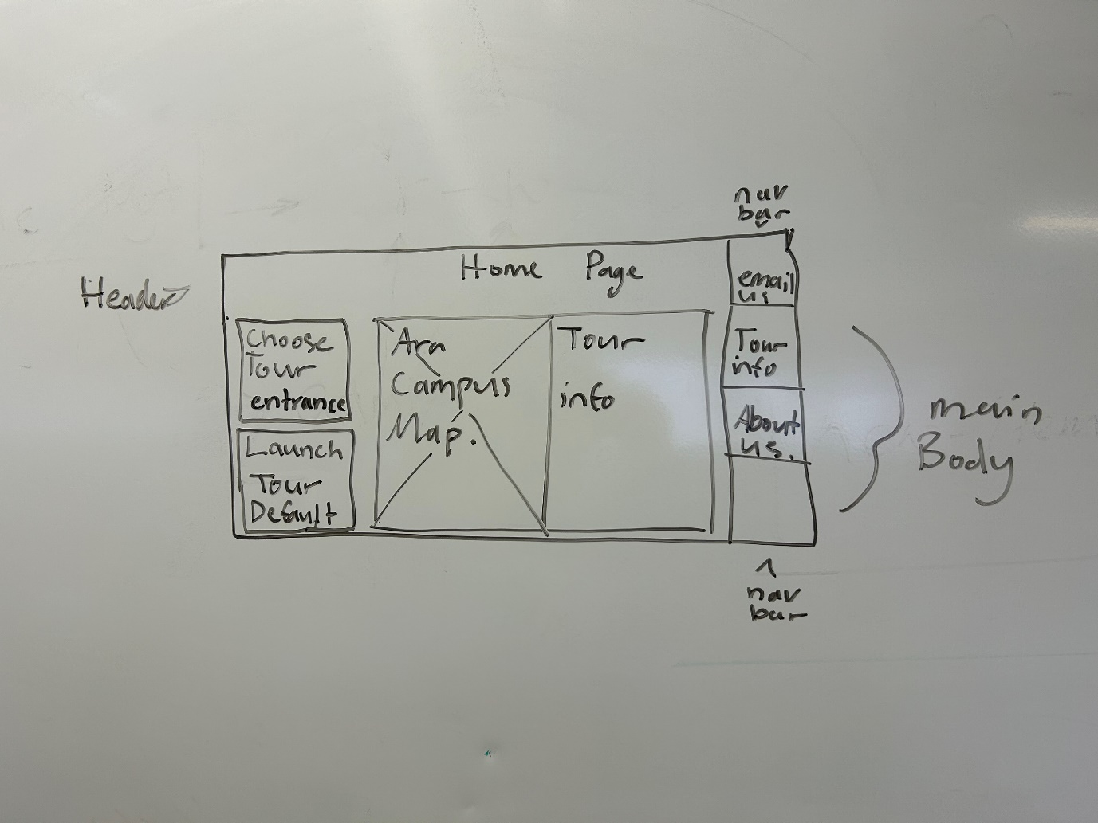

**Figure 4**  
*Ara about us page Low fidelity prototype*

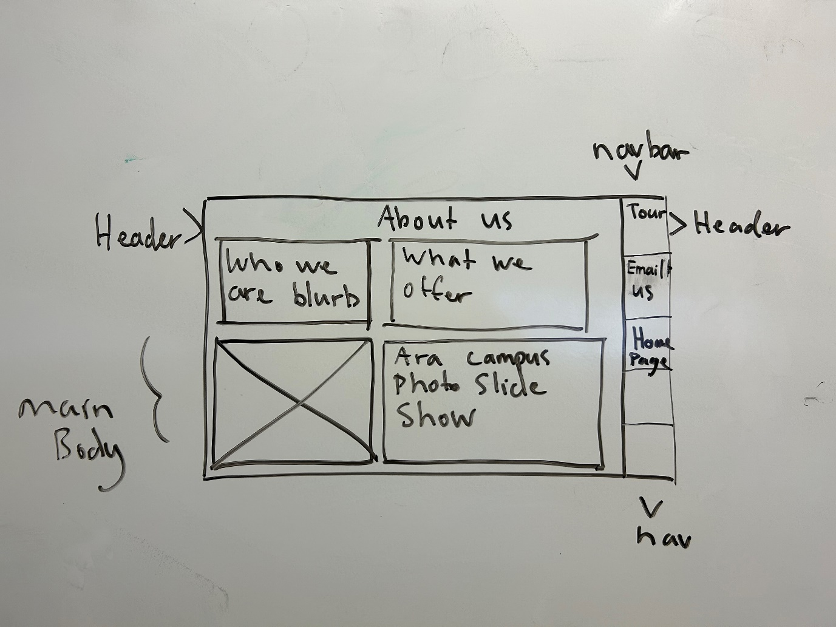

**Figure 5**  
*Ara about us page wireframe low fidelity prototype*

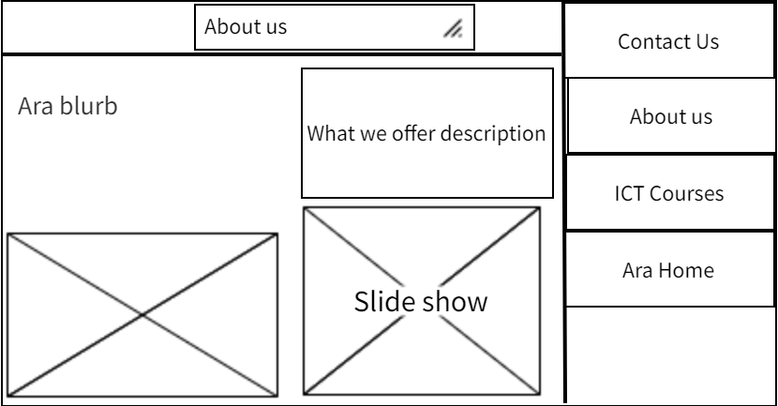

**Figure 6**  
*Ara Lapentor Low fidelity prototype.*

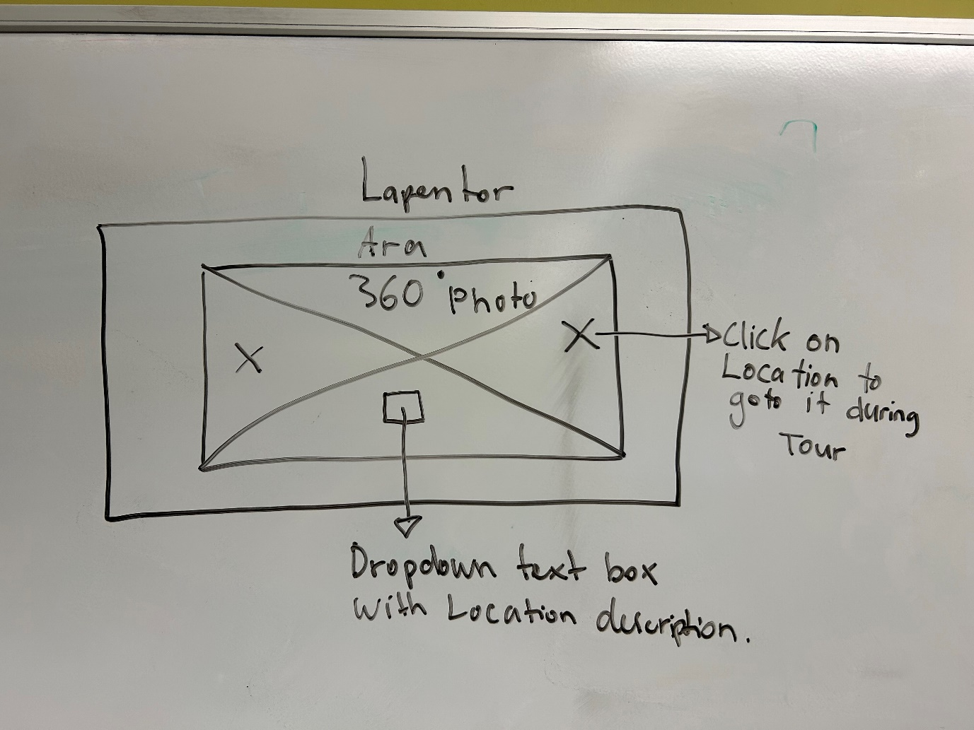

**Figure 7**  
*Ara Campus Map – Highlighted areas of interest for 360 tour.***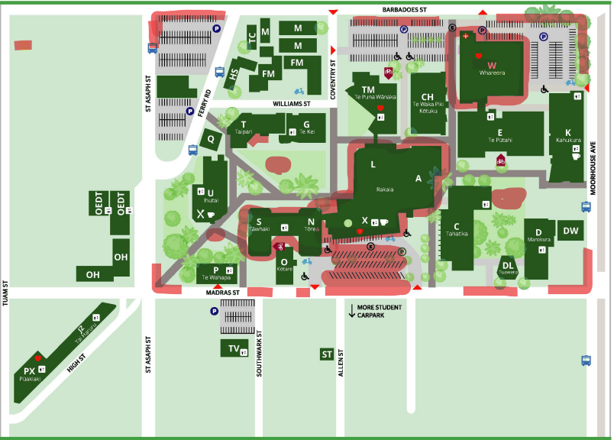**

### High Fidelity Prototype

#### High Fidelity 1:

From my lo-fi prototype, I produced a very simple layout for achieving an Ara homepage to launch the virtual tour from. I also put all the images into the Lapentor tour and made the campus tour able. Although some characteristics of the tour were missing, and it felt quite bare. However, I went ahead with my first iteration of testing (functional and usability testing) after I produced the following.

**Figure 8**  
*

**Figure 9**  
*First iteration of high fidelity prototype on Lapentor*

I performed functional testing to ensure that key aspects of how my product functioned were working. I found that I was missing a html page for the ‘information’ button, and therefore couldn’t also return to the home page if I clicked this button. Otherwise, the rest of my tests passed.

**Figure 10**  
*functional testing plans round one.* 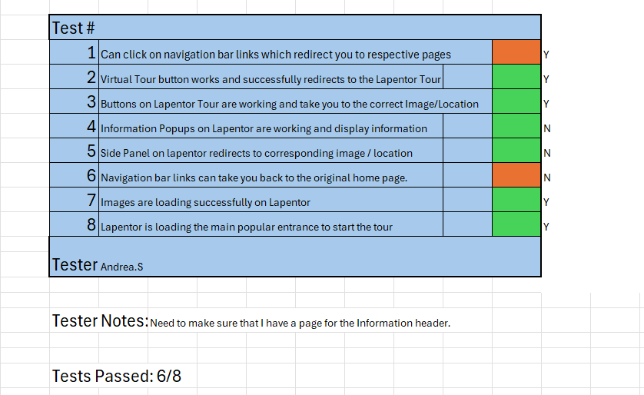

From these tests we can analyse the results. We clearly needed working navigation bar links to direct us to the correct pages. This was to be dealt with in the next iteration development. There also was no page added to direct back to the home page, similar to the above issue.

After I performed these tests, I then proceeded onto the Usability testing with my first tester, Andrea. S.

**Figure 11**  
*Usability tests round one.*

These are the tests I gave her, and this is the feedback I was given: ‘*The tour felt very bare and minimum. Especially the home page that it was launched from. It needs to look more professional. You should also add more information popups because it was very difficult to find the one that I found. The home page has barely information displaying on it as well. Also, your links in the navigation bar aren’t going anywhere for the information NAV’.*

This was some very valuable feedback, and so I immediately got to work producing a better product.

#### High Fidelity 2:

For my second iteration I decided to update my outlook on the prototype. Instead of adding a page for the information aspect, I added it to the home page and deleted the ‘information’ navigation bar, therefore the only navigation bar option was Virtual Tour. I feel like this made it simpler to use. We will find out through testing however, if this is true. I also added some information on the ICT sector at Ara, and what they offer to make the page more populated and less boring. I also changed some slight colour scheming and tried to make it look more professional which will also be reviewed in the corresponding tests.

**Figure 12**  
*Second iteration of Ara home page.*

**Figure 13**  
*Lapentor virtual tour page iteration two.*

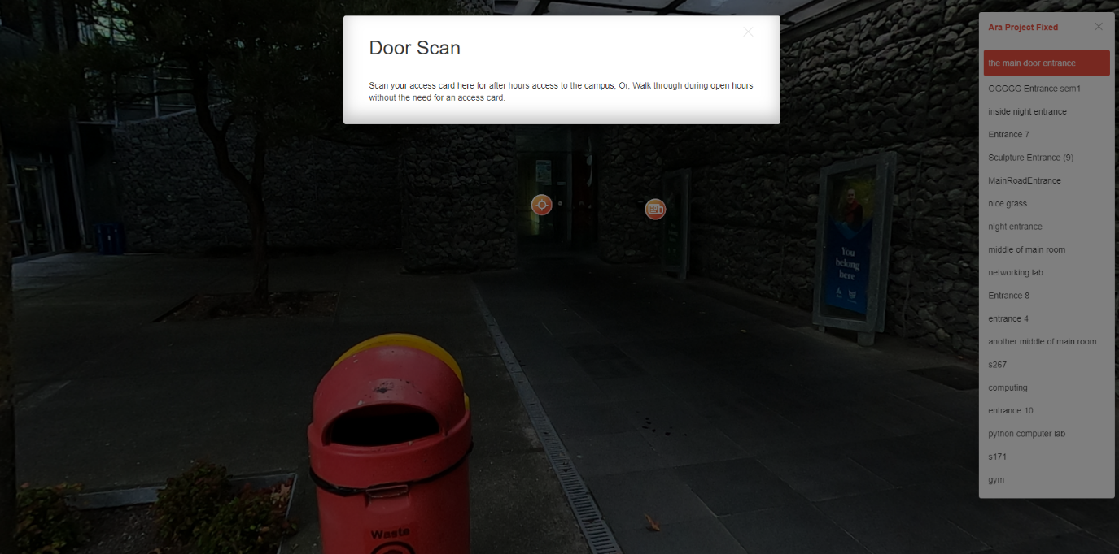

**Figure 14**  
*Updated Lapentor virtual tour page.*

**Figure 15**  
*Functional tests round two*

I noticed after doing my functional tests for the second iteration that some of the image names for the scenes had interesting names as I named them with what I remembered when making the virtual tour. Depending on whether they are simple to change, if I can’t change the names then I think it is outside of scope to restart the Lapentor project to rename them as this would take up too much time. The bare minimum project requirements or MVP can still be achieved with the interesting naming conventions.

**Figure 16**  
*Usability tests round two.*

**Tester Notes:** The site is quite simple to use, are you sure you don’t want any other information in the home page? The images in the tour also look a little bit dark in some places. The font styles and colouring are also quite basic, I’m not sure if that’s what you’re going for, but I think it could be updated. You also don’t have much information on where you are in the tour, if you are a new student, it would be quite difficult to know. I also noticed that the virtual tour button should be named ‘Launch Tour’ or ‘Launch virtual Tour’ because of the wording in the paragraph on the home page.

#### High Fidelity 3:

From the above results, I concluded that I should update some styling and fonts on my page as they were all set as basic default fonts. I also considered updating the colour scheming but thought it suited quite well considering the Ara colour scheming requirement. I also decided to add even more information points through the virtual tour as I still had quite a minimal amount. And I also added some key information points about where they were. Some of the point indicators on Lapentor also were named interestingly so I investigated whether I could change them. I also decided to keep the one ‘launch tour’ button as the only nav bar link because there was no need for anything else. The key was ease of use from the client so this can be specified with the client after the end prototype is presented. I also changed the name of the virtual tour button that launches the Lapentor page.

**Figure 17**  
*Third iteration home page design.*

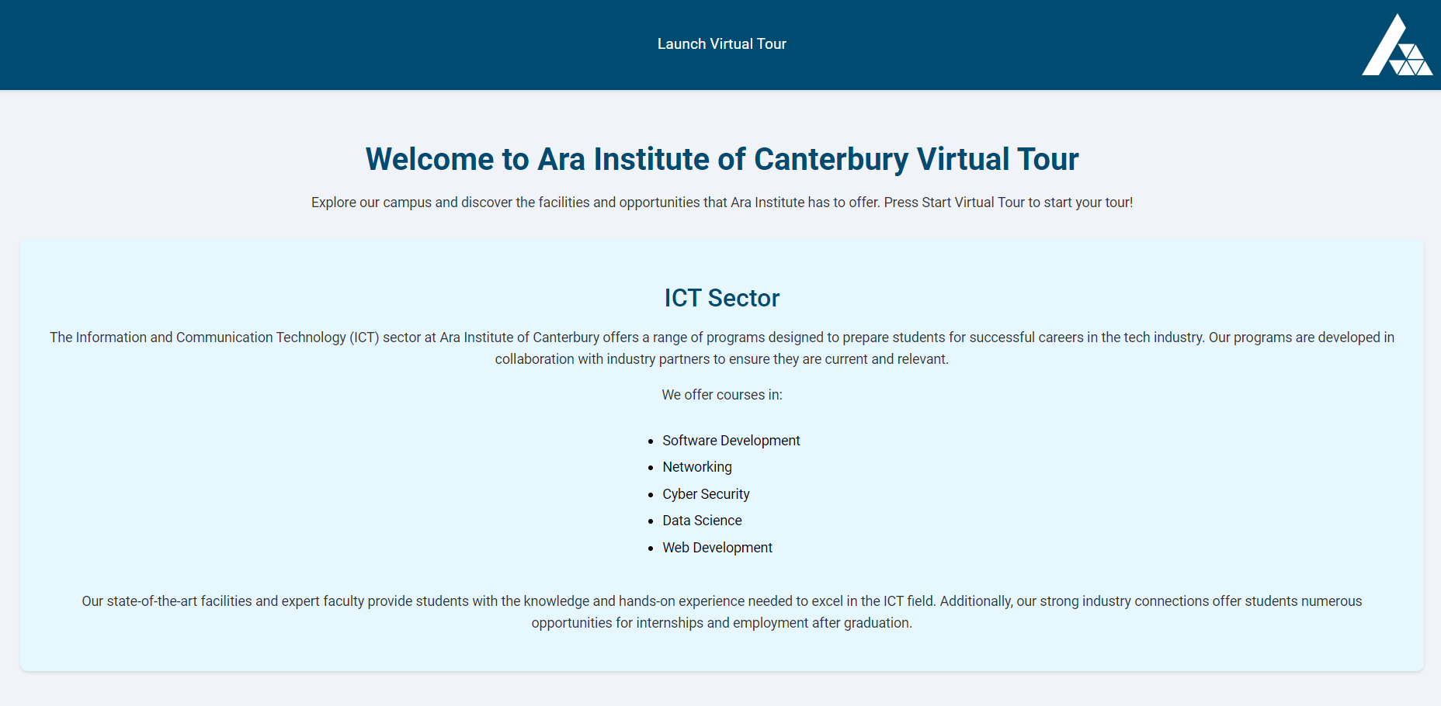

For the final stage of prototyping, my product that was being tested had updated colour scheming to reflect a more professional look, A new Ara logo which was white to fit in the background of the header, and the tour button had been changed to be situated in the middle of the nav bar header, with the words ‘Launch Virtual Tour’.

**Figure 18**  
*Lapentor virtual tour updated image location names.*

From the above image, I updated the scene names to give them a more accurate and professional naming style. Originally, they had names which only had personal meaning to me, but I went through and individually changed them so that it promoted ease of use for the customer or user. (I finally find the edit option it was right in front of my face).

**Figure 19**  
*Functionality tests round three.*

**Figure 20**  
*Usability tests round three.*

**Tester Comments:** A nice looking and simple sleek design, but I think you could maybe use some sort of indicator around the launch button to indicate that it’s a clickable button. I sort of had to think for a bit about where to launch the tour from. Some of the images were a wee bit dark, like I couldn’t see inside of the cafeteria in one of the photos, and there isn’t much help with where or what is going on in the auditorium. You should really update this. Also, some of the images are a wee bit jumpy and not completely clear on where you are going, maybe you could add more images?

#### Presentation Product

From the third iteration of testing, I concluded that I needed to have specific location popup / information popups in the auditorium to indicate to people where specific things were like student resources / finance, and student support etc. There was also one problem that some of the photos were a little bit dark however, it was out of scope to get new images so I had to stick with the current images which in my opinion worked but I could agree were on the bare minimum end for the product. Two of my tests failed due to this but the above solution should hopefully fix this. Roger also pointed out that some of the images weren’t so clearly connected, and I should add more images. This again was out of scope as the client specified that they didn’t want a paid solution. To use more images in Lapentor I needed to pay for the premium version, and in my opinion, I selected the best images which fit within the allowed amount of 30 images of the campus. Therefore, for my final product, I am going to update and add more information about what is in the surrounding image, which should help clear up for the user where they are and what surrounds them, especially in the auditorium. I also added the functionality or code for making the button look like it’s a button, or at least changed the background colour of it to achieve a more ‘buttony’ button.

I also chose to add a footer with copyright of Ara information and chose to re arrange the main information on the page. The final product I came up with was the following for the home page:

**Figure 21**  
*High fidelity presentation product – home page.*

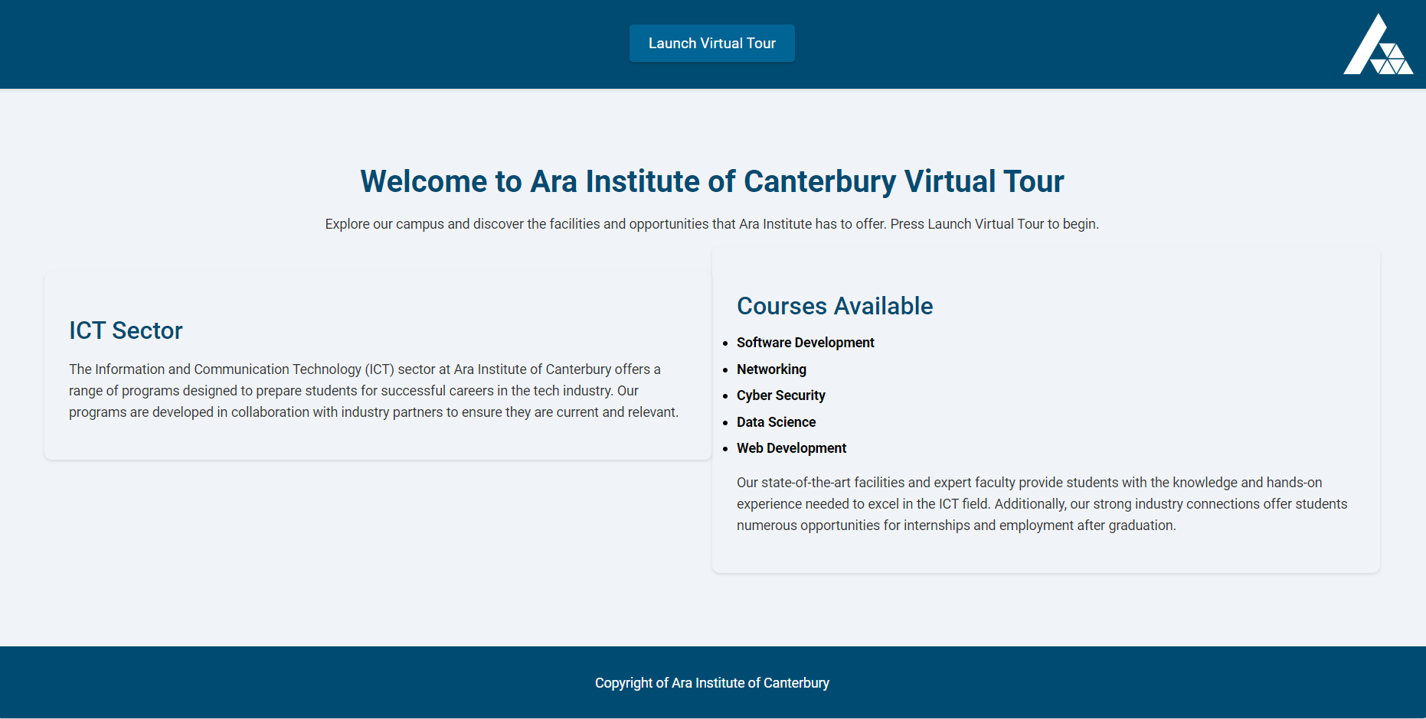

#### Post Presentation Product

Once I had developed my ‘mock up’ final product, I had to present it in front of both my classmates and my client. From this I was able to gather a list of things I may be missing and some things I need to change and work on. This was like a big round of usability testing

Through a mental transcript, I remembered the following things from my presentation:

* Chris, the client, commented that my web page needs to have another look at the styling as the word formatting and centring isn’t quite right. It needed to not be so centred.
* Chris and David, (David being the academic supervisor), commented that I was missing navigation links to the Ara home page for the ICT degree pathway options.
* Chris also mentioned the button on the home page needed a rethink as it was still too dark, and he wasn’t so sure where to click at first glance.
* David mentioned that the Lapentor tour needed to have limits added for each image, so that the ground where the camera legs are can’t be seen.

Therefore, I went back and added all these features which were asked for and conducted a round of functional testing to ensure what I had added (mainly the navigation bar with Ara links), was working.

**Figure 22**  
*Final Product home page for Virtual tour.*

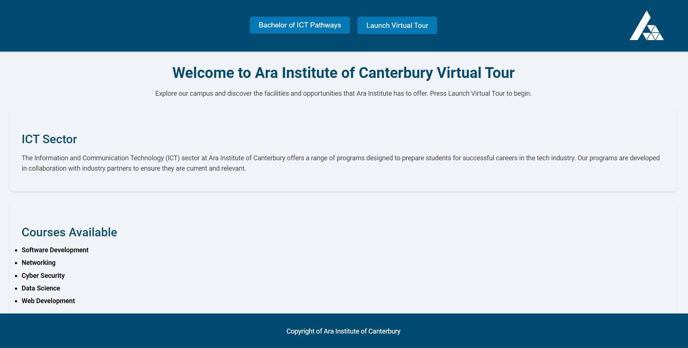

Using the Bachelor of ICT pathways button at the top, extended a menu of three options to choose from the three BICT degree pathways offered at Ara with their respective Ara page links with information.

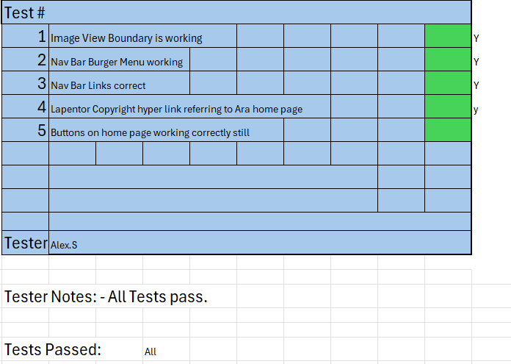

My final iteration added the following attributes to the project:

* Added view boundaries so that the camera in Lapentor can’t be seen from the bottom of an image.
* Added appropriate default view on Lapentor tour.
* Added Appropriate hyperlink for the Copyright on Lapentor page and added the correct URL to redirect to Ara home page.
* Added Ara Logo to Lapentor Tour.
* Added extra buttons on home page, which brings down a burger menu of BICT pathways offered at Ara – and added their respective links.
* Restyled buttons on home page so that they look more obvious while sticking with appropriate colouring and styling (using Ara styling)
* Changed flow of information layout on home page, (made information and content stack vertically, per request of the client).

# Reflections

The key take-homes I found from creating this proposal documentation was that the project is and has required a lot of time and resources to successfully plan what will or should happen. I am surprised that this much time has been taken up to create this document, yet no significant Hi Fidelity prototype has been created yet. However, I think there are some major positives to take home, mainly being that the project has a strong foundation for its creation and should hopefully have a good direction to be lead in due to the documentation in this report.

For the next phase of the project, I will need to more deeply consider adding more to my specifications document and will also need to look at a more in-depth analysis of the prototypes, as I ran out of time to significantly complete the documentation for this part of the project proposal.

However, I will not let this adversely affect the outcome of the project and will make sure to put extra time aside to complete adequate documentation for the project going forward.

## Approach

During the creation of this document, a significant number of learnings have taken place, many being for example, learning about industry standard development methods, risk assessment, quality assurance and much more. This information has been added to this document and updated as I learn, ensuring that my learnings are being applied to their best abilities which may aid the production of this virtual tour. Key reflections and take homes will be talked about and analysed in a final project reflection when the product has been created and distributed to the client.

## Final Project Completion reflection

Through completing my final project, I created a, what I would like to say, high quality minimum viable product which Is capable for professional use. Although there may be some small aspects which could be worked on, I am happy with what has been produced and the work I have conducted. One thing that I feel took up some of my time is the documentation of things like risks, development methodologies and the project plan. However, I think in the grand scheme of things, it is a small price to pay to ensure quality and best practises throughout. My usability and functional testing were crucial to developing a quality product. My functional tests ensured that everything code related was working as it should, for example, page links and buttons are all working. My usability testing ensured that the applications created could be used appropriately, and the end goal of what I was producing was able to be achieved. Usability testing also gave me important feedback for further developing my product for my client. I found it rather difficult at first to work with HTML and CSS as I hadn’t used it much over the last year, but it soon refreshed and came back to me. I also found it difficult at first to use Lapentor, however, I also soon learned how to use the application relatively efficiently. By the end, I had learnt a lot about developing a quality end product using both raw code input (HTML,CSS), and the Lapentor virtual tour tool. I also learnt about the importance of developing a product in cycles or fidelity iterations to allow for small changes at a time.

# References

# Bibliography

Ahmad, M. O. (2013, September). Retrieved from https://www.researchgate.net/publication/260739586_Kanban_in_Software_Development_A_Systematic_Literature_Review

Ara Institute of Canterbury. (2020). *Ara Strategic Focus Area and Priorities.* Retrieved August 10, 2020, from Ara Institute of Canterbury: https://www.ara.ac.nz/__data/assets/pdf_file/0005/614534/04508-Ara-Strategy_2020_A3_WHIT

Ara Institute of Canterbury Limited. (2020). *Ara: About Us*. Retrieved July 31, 2020, from Ara Institute of Canterbury: https://www.ara.ac.nz/about-us

Ara Institute of Canterbury Limited. (2020). *IT Infrastructure*. Retrieved July 31, 2020, from Ara: InfoWeb: https://infoweb.ara.ac.nz/our-teams/corporate-services/ict

forgemountain. (2024). Retrieved from https://forgemountainphoto.com/photography-services/360-photography/benefits-of-a-virtual-tour/

HAYES, A. (2024, february). *what is six sigma?* Retrieved from investopedia: https://www.investopedia.com/terms/s/six-sigma.asp#:~:text=The%20Six%20Sigma%20method%20uses,by%20following%20these%20five%20steps.

Hayuhardhika, W. (2020, August). *project management systems using kanban methodology*. Retrieved from researchgate.net: https://www.researchgate.net/publication/343924734_Software_Project_Management_Systems_Using_Kanban_Method_in_the_CV_Primavisi_Globalindo

hotpmo. (2024, april). *User Personas: What are they and how can they help you?* Retrieved from hotpmo user personas, what are they and how can they help you?: https://www.hotpmo.com/management-models/user-personas-what-are-they-how-can-they-help-you/

iqanz. (2024, april). *Common IT Project Risks*. Retrieved from iqanz.com: https://iqanz.com/technical-quality-assurance/common-it-project-risks/

ITIL Service Management Practices. (2007). *The Official Introduction to the ITIL Service Lifecycle.* London: TSO.

itp.nz. (2024, april). *Code of Ethics*. Retrieved from itp.nz/codeofethics: https://itp.nz/codeofethics

Lancaster, O. (n.d.). ICT statement.

maze. (2024, april). *how to run website usability tests*. Retrieved from maze.co/guides: https://maze.co/guides/usability-testing/website-usability-testing/

NZ Government. (2020). *Privacy Act 2020 and the Privacy Principles*. Retrieved from privacy.org: https://www.privacy.org.nz/privacy-act-2020/privacy-principles/

Son, H. (2023, august 21). *How to create a test plan*. Retrieved from testrail.com: https://www.testrail.com/blog/create-a-test-plan/

# Appendices

## Appendix A – Detailed Project Plan

Refer to the document attached in the form of an excel file – BCDE_311_Ass3ProjectPlanAndPhases_AlexStewart.xlsx (updated final version).



## 

## Appendix B – Risk Management Tables

**Table 4**  
*Risk management table version 2*

|  |  |  |  |  |  |  |  |  |
| --- | --- | --- | --- | --- | --- | --- | --- | --- |
| Risk # | Risk condition | Consequences | Probability of occurrence | Impact Score | Mitigation | Contingency | Triggers | Exposure Score |
| 1 | Project Worker Sick/Injured | Project development will come to a halt causing delays and potentially meaning the project time frame will need to be extended | 50 % | 9 | Eat healthy, complete work on time, don’t take physical risks, stay away from sick people, take vitamin c | Visit GP, eat healthy, rest well, use laptop while resting if I am well enough to use | Runny nose, Sore throat, Broken bones, fever symptoms. | 4.5 |
| 2 | Equipment Stolen/Broken | Data loss, pause in project development, money loss. | 25 % | 9 | Keep equipment in a safe kept place | Ensure devices have passwords, ensure data is backed up on the cloud, have backup equipment available. | Equipment visibly broken or stolen. Slow laptop | 2.25 |
| 3 | Internet Outage | No communication between me and client, cannot produce work for the client either / work on project. | 10% | 9.5 | Choose strong internet provider, use a trusted provider with good security and up time | Ensure I have a secondary location to goto which has internet, in the case that my current location has an outage | Internet not working | 0.95 |

|  |  |  |  |  |  |  |  |  |
| --- | --- | --- | --- | --- | --- | --- | --- | --- |
| 4 | Data breach or Hacked equipment | I will have to use time and resources to either get them back or renew the equipment. It will also use my time of which I am using on the project. | 5% | 8 | Use reliable data keeping services, also use reliable operating system, store data securely with encryption. | Keep data stored on a cloud as a backup, in the case that it Is seized or stolen. Have backup equipment if possible | Equipment has virus, data is missing. | 0.4 |
| 5 | Project burn out | Will lose motivation to complete the project as I have been doing too much work on it in one period. Project can start to lack behind schedule. | 10 % | 2 | Make sure you are completing the correct amount of work every week, and not over working yourself in certain periods of time | Take a day to rest mentally and re assess what you should be doing. (maybe use motivation that you need to do it because you want a degree) | Poor motivation, over worked. | 0.2 |
| 6 | Electrical Outage | Access to developing the product will be halted as the computer required to develop wont be able to turn on | 1% | 5 | Make sure all work is being kept on top of and completed as per project timeline | Create a plan during power outage for how you’re going to efficiently complete work when power is back on | No power. | 0.1 |

## Appendix C – Quality Assurance Tables

**Table 5**  
*Quality assurance table version 2*

|  |  |  |  |  |  |  |
| --- | --- | --- | --- | --- | --- | --- |
| **Project Deliverable** | **Quality measure** | **Quality assurance activity** | **Frequency / Occurrence** | **Who is responsible** | **Due date** | **Date of acceptance** |
| **Project proposal** | Acceptably covers the scope of the project | Submit the report draft to tutor | Twice | Alex Stewart | Friday, 12 April 2024 | 17 April 2024 |
| **Project Plan** | Correctly displays the project outline and phases that it will go through | Submit the report draft to tutor | Twice | Alex Stewart | Friday, 12 April 2024 | 17 April 2024 |
| **Risk management plan** | Covers 5 likely/significant risks which may occur during the project | Submit the report draft to tutor | Twice | Alex Stewart | Friday, 12 April 2024 | 17 April 2024 |
| **Quality assurance plans** | This table | Submit the report draft to tutor | Twice | Alex Stewart | Friday, 12 April 2024 | 17 April 2024 |
| **Testing plans** | Functional and usability tests cover a proficient range of project requirements. | Submit the report draft to tutor | Twice | Alex Stewart | Friday, 12 April 2024 | 17 April 2024 |
| **Specifications documentation** | Detailed coverage of requirements for the project. | Reviewed by tutor (through group member) | Completion | Alex Stewart | Friday, 12 April 2024 | 17 April 2024 |
| **Lo-Fid – Prototype** | Meets client requirements and demonstrates a simple solution | Review by tutor and client and or a user tester | One | Alex Stewart | Friday, 12 April 2024 | 17 April 2024 |
| **Hi-Fid Prototype** | Iterates from the low fidelity prototype and demonstrates a more accurate depiction of the final product as per client requirements. | Review by tutor and client and or a user tester | 2 or more | Alex Stewart | 31 May 2024 | NA |
| **Hi-Fi-Prototype documentation** | Documents testing results from the hi-fi prototype adequately. | Review by tutor, at least 2 iterations of functional/usability testing performed | 2 or more | Alex Stewart | 31 May 2024 | NA |
| **Final Documentation** | This document should be updated appropriately with all details, and uploaded supplementary documents should be up to date and uploaded along side it. | Review by tutor. | One | Alex Stewart | 18 June 2024 | 18 June 2024 |

## Appendix D – Client Interview Transcript

Interview with Client – Christopher Bartlett.

This interview also has our tutor David Weir participating.

Group members: Jem, Alex, Sam, Geoffrey.

Alex: Now would you be able to tell me how long they (ara) have been around for?

Chris: 11 years.

Alex: who would you say the main users of this product will be?

Chris: New students, particularly ones who are studying ICT, and potentially parents but mainly students.

Alex: what details or contents would you want to be in this project?

Chris: well fundamentally it’s a virtual tour, so content will primarily be a visual in a guided way around campus, focusing on the campus here, we don’t need anything for the other campuses, so its areas on campus that would be relevant to ICT students. Potentially some text explanation here and there

David: its an orientation, yes fundamentally there is a tour but what happens during orientation?

Alex: what would you like your users to see or feel when interacting with the tool?

Chris: it needs to be easy to understand so ease of use is huge , it’s a significant point, and needs to not have a large amount of explanation to use. If you have to give explanation about how to use then keep it minimal.

Alex: will there be any areas in particular that we should look out for?

Chris: potentially balancing the amount of detail you have got, not too much information that people are getting over whelmed. Don’t leave things out, if I tell you I want to see it then it needs to be in there. Don’t go thinking oh I thought this was interesting so ill add it, ill let you know what you need to do and if you have any questions about what needs to be in there.

David: you need to be aware of privacy > images that contain identifiable people at ara are an issue that you need to be aware of, you can’t use an image with an identifiable person unless you have their explicit consent. The way around it is that you can post an image, edit and blur, their faces which is something that you need to be aware of. So be mindful of who is in the images yea? okay?

Alex: how do you envision the final product will look like, could you give us a brief description of it?

Chris: well, I’m interested in what you will show me I suppose. Not having built this kind of thing myself before, id be interested to see what you can come up with. We are focussing on clarity and ease of use.

Jem: When it comes to accessibility do you want this product to have elements of responsive design?

Chris: What do you mean?

Jem: Like you can use it on phone, laptop,

Chris: uhm yes? Its 2024 the answer is an automatic yes these days,

Jem: can you discuss what is the actual interactions the user should have with this project?

Chris: ill be interested to see what you come up with, im not sure whats possible, ive got more goals in mind versus the way you actually use it.

Jem: do you want to keep the colour schemes and styles from the official ara website?

Chris: yes we need to do that, I think its semi official

David: it falls under that it’s a symbolling of ara, yea so its kinda under that hierarchy, so yes you will have to have ara in it.

Chris: that sort of suggests its not apart of the ara apartment itself, but it is.

Jem: do you want us to use the design of ara or te pukenga

Chris: that’s disspearing

David: that will cease to exist so stick with ara

Jem: what media elements do you want to include in this product?

David: all the fundamental media elements you know about, you will be able to include, appropriately.

Chris: do we have sound files? Yea I’m not sure.

Jem: do you want us to use sound files.

Chris: yea well I kind of envisioned it as a visual walk through, you know, it might be a bit much for a first iteration of something.

David: it could be an option.

Chris: we have iteration in mind, so you could have someone narrating and telling them whats going on, uhmmm, potentially, if its something you have time for and you have touched on the must have aspects, then sure. But if it takes too much time awa from the core requirements then no.

Jem: do you want us to include some sort of description of where they are?

Chris: yes because it’s a orientation tour so people need to know some sort of description of where they are ,

Jem: uhmmm, do you want to see and be involved In the initial prototype?

David: that happens towards the end of your initial development, and you will need to be getting some feedback from your client but also your USERS on an iterative basis!

Jem: do you want the initial prototype to be on software or paper

Chris: given the nature, paper isn’t going to give me the interaction with the product, so it might have difficult to envisage paper prototype.

Geoffrey: do we have access to the original resources, like logos and pictures,

Chris: yep, logos, we have ara branding and access to those

Geoffrey: how many pictures do you want for one location?

Chris: well its 360, so its how many you need per location, whether its one or more.

David: hang on, I showed you a 360 camera in class, it takes a 360 panorama , so each location with that camera will create one photograph of the entire 360 sphere that you take it in, alright?> that’s called a photo sphere okay?

Sam: how many different picture locations

David: that will be advised

Chris: well I have a list so ill send it through to you, but just so you have a sense for it, we need to see the entrances, the carpark, the main ict computing office, areas where our staff offices are, the main class rooms, x block, s block, n block, w block that as well, and the main atrium, student servies, help information etc. it support, gym student help, main carparking off barbedos, student lounge, that still exists doesn’t it? The c block one, yea, that’s the primary list.

Geoffrey : would you like any locations to be a main focus?

Chris: Well you need to start at a main entry point but that doesn’t make it the main focus, so not really, because you need to get around these things.

Geoffrey: what about a landing page?

Chris: so if someone comes into tour about the virtual tour, they come into a landing page with something about the virtual tour, but they will probably start at the statue main entrance, because that’s the main one from town

David: I think that’s entrance seven or eight. Theres exit seven over there.

Sam: are these on the campus map?

David: yea I think they should be on the map.

Chris: yea I think that one because its quite visible because of the sculpture there.

David: a landing page, I think there’s two things going on here isn’t there, as Chris said, there’s going to be a landing page which has the links to all the info, and then there is where do you start your tour from. But the ability to select where you start your tour from might be important right from the word go, I will show you in class, you can decide where to start if you give people the option to start a tour at Barbados street, then that’s where it will start. You need to investigate how you will make that happen, or as a default if you can’t figure it out then they start there, but there will be many options to allow people choose which entrance they want to start from.

Geoffrey: what kind of weather do you want the photos taken in.

Chris: consistent and bright and sunny without a cloud in the sky

David: think about what’s happening now that we are in autumn and the seasons will rapidly change and so will the trees, and there is a fundamental problem with doing these kinds of tours that when you take photographs in the middle of winter, it makes the places look dreary. We see disconnects on some of the previous ones we have done some time ago, winter semester starts, and they waited and waited and waited, and then went out and took a whole bunch of photographs in the springtime. Occasionally there is a disconnect because some photos just aren’t consistent.

Geoffrey : do you want any activites to be highlighted, like basketball?

Chris: no, but show the facilities like whaeroa building and the gym.

Geoffrey: do you want other campuses or locations to be?

Chris: no no we don’t.

Geoffrey: do you want all locations to be listed or only accessible stuff to students.

Chris: there will be some you will need to show, you won’t be wondering into security, but you will still need to show the outside of security, the help desk, you don’t need to go in but you still need to show the building or where it’s from.

Geoffrey: do you want language options for different students.

Chris: that’s nice to have, I think we will put that on the version two list, it will be probably just enough to get the initial version going,

Geoffrey: what languages do you want to include?

Chris: we will discuss that.

Geoffrey: what are the must have features of the software.

Chris: I can’t think of anything, I think we have covered them already.

Geoffrey: could haves?

Chris: already covered them, no additional ones.

Geoffrey: are there any specific interactive elements for users when exploring the 3d orientation tool?

Chris: information hotspots would be nice, recordings of people talking which I hadn’t thought about, but you can bring up text descriptions.

David: you can have other images, videos, any element is possible you just must work out how to make it present and accessible, and consistent. It could be anything. They can all be included. You just need to find an appropriate place for them

Geoffrey: do you anticipate the need for customisable features within the 3d orientation tool such as the ability to tailor content based on user roles.

Chris: no

Sam: do you want hands off near zero interaction with the back end, like server maintenance and maintaining things.

Chris: yes, I’d hope so.

Sam: will the solution be locally hosted or another company.

Chris: we find it difficult to get hosting here from ara, for things like this, so initially you will need to have your own hosting facility. It should be portable to anything if we can host it down the line.

Sam: do you want to be able to edit the solution via admin options so you can log in and change some things if you can so desire.

David: at some stage yes because there will be the need to update stuff down the line.

Chris: its not its not its probably not a version one feature so much yea,

Sam: is there a budget allocated for paid solutions:

Chris: no

Sam: do you want a proof of concept or a standalone solution ready for hand over.

David: the scope will enable you to produce something that is ready to be deployed, that would be quite capable in the time span that you have got. Maybe not all the wish to haves, but the must have’s yea.

Chris: yea we have flagged everything we want. If clarification needed, then just let me know.

Sam: do you want an option for delivering feedback after they have completed the tour?

Chris: not in version one, it sounds like its coming away from the core needs.

Sam: do you have plans for future expansions or updates to the tool, and do you see new content being added down the line.

Chris: no

Sam: are there any KPI’s you would like us to measure for effectiveness in relation to the tool?

David: are you talking about after its deployed?

Chris: well, there should be enough testing before it was deployed to verify that it works?

Alex: do you want anything to verify people are using the tool?

Chris: no

David: we will be creating the access to a stored repository information where that key information will be available.

**Interview is wrapped up.**

### Signed consent form:

